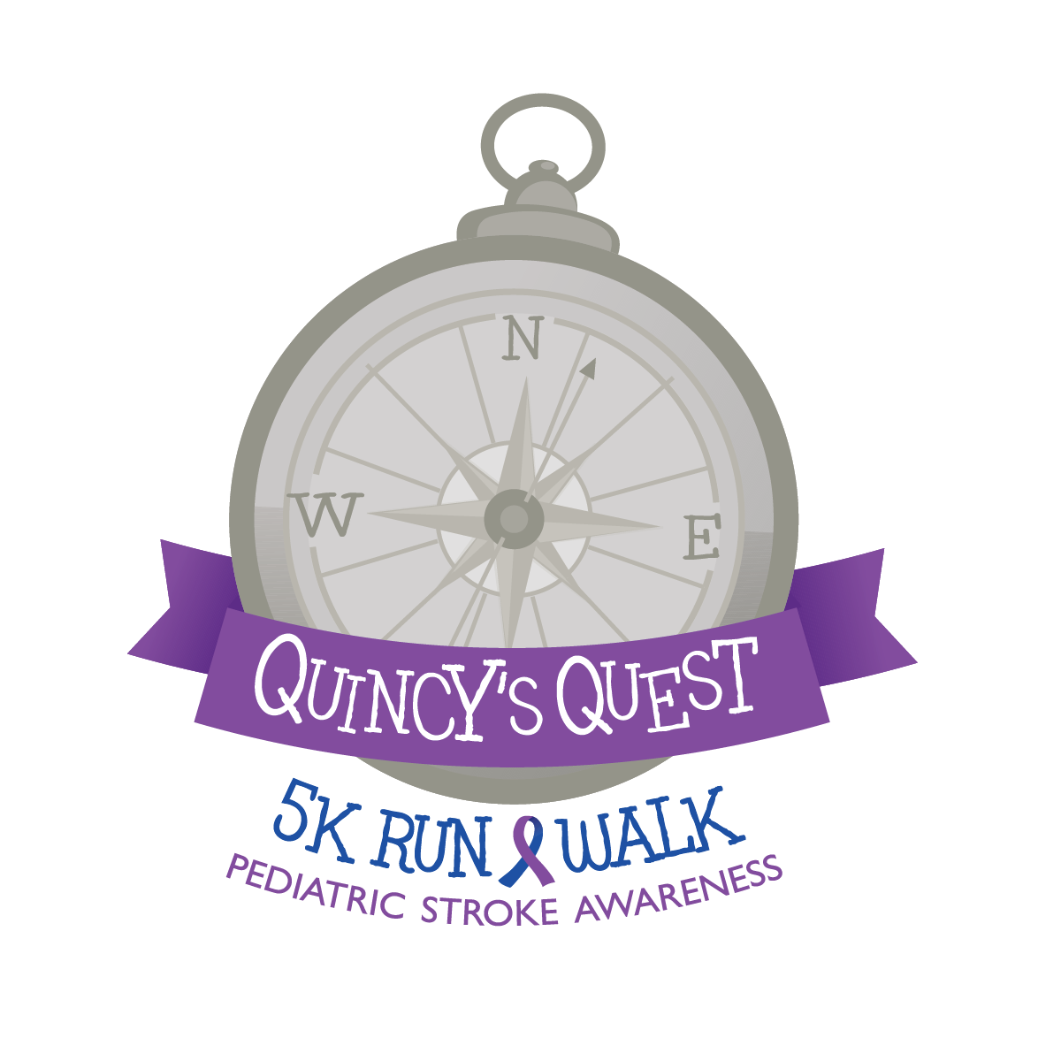

Donation Form

Name/Phone Donation

1._____________________ $

______________________

2._____________________ $

________________________

3._____________________ $

________________________

4._____________________ $

________________________

5._____________________ $

________________________

6._____________________ $

________________________

7._____________________ $

________________________

8._____________________ $

________________________

9._____________________ $

________________________

10._____________________ $

_________________________

11._____________________ $

________________________

12._____________________ $

_________________________

**Quincy’s Quest**

**1089 Mitzler Road Alum Bank, PA 15521**

**www.quincysquest.weebly.com**

**Every dollar counts! Encourage friends, family and co-workers to sponsor you as you walk or run for pediatric stroke awareness!**

**Return Donation Forms and Donations by:**

**1. Mail** to Quincy’s Quest (address below) with your attached race registration form.

**Remember:**

* Keep registration fee and donations separate.
* Donations are due May 10h, 2015.

2. **Hand In** on race day at the registration table.

Your information

Name: _________________________

Address: _______________________

_______________________________

Phone:_________________________

Email:_________________________

Quincy redefines the word fighter each and every day. He has surpassed the grim beginning prognosis and is still gaining ground each day. Quincy giggles, smiles at his two older brothers, and babbles at his "dada". While the right side is still weak and preventing Quincy from sitting on his own for extended amounts of time he shows great patience and enjoys therapy five times a week with a team of therapists.    
In celebration of Quincy's first year we invite you to participate in "Quincy's Quest" to help raise awareness of pediatric stroke. Proceeds from Quincy's Quest will be donated to CHP Ronald McDonald House.

Shawnee

State Park

May 10th, 2015

2 p.m.